CDDO
Community Developmental Disability Organization

Things to Know About Your CDDO
Your Single Point of Entry for Miami, Anderson, & Linn Counties

www.tri-ko.com/cddo
301 First St. Box #2
Osawatomie, KS 66064
Tel. (913)256-7013
Fax (844)272-3771
2/2/2024

Table of Contents
Acronyms 2
What is a CDDO? 3
I/DD Waiver Service 4-7
Eligibility Definition 8-9
Funding Sources & Services Flow Chart 10
Waiting List 11
Continuity & Portability 12
Affiliates 13-14
Targeted Case Management/PCSP 15
Changing Providers 16
Disputes 16
Reporting Abuse, Neglect, or Exploitation 16
Rights 17-19
KanCare 20-24
Newsletter, Website, & Feedback 24
List of Acronyms

• ANE – Abuse, Neglect, Exploitation
• APS – Adult Protective Services
• BASIS - Basic Assessment and Services Information System
• BSP – Behavior Support Plan
• CDDO - Community Developmental Disabilities Organization
• CINC – Child In Need of Care
• CPS – Child Protective Services
• CSP - Community Service Provider
• DCF – Department for Children and Families
• EDI - Eligibility Determination Instrument
• ELP – Essential Lifestyle Plan
• HCBS - Home and Community Based Services
• HCP/CSS – Health Care Policy/Community Support Services
• ICF – Intermediate Care Facility
• I/DD – Intellectual/Developmental Disability
• IEP – Individual Education Plan
• IJP – Individual Justice Plan
• KDADS – Kansas Department for Aging and
Disability Services
• MCO – Managed Care Organization
• MH – Mental Health
• PCSP - Person Centered Support Plan
• POC - Plan of Care
• QA - Quality Assurance
• SSA – Social Security Administration
• SSDI – Social Security Disability Insurance
• SSI – Supplemental Security Income
• TCM – Targeted Case Manager

What is a CDDO?
A CDDO or Community Developmental Disability Organization is the single point of application, eligibility determination, and referral for individuals and families to obtain services through the developmental disability system in the State of Kansas. CDDOs determine whether a person qualifies for services and work with the person and/or their family or guardian in choosing from an array of service options. In addition to this, CDDOs impartially provide information about all types of community services and other resources in the area.

Kansas currently has 27 CDDOs, each of which contract with the Kansas Department of Aging and Disability Services (KDADS) and are assigned a particular county or group of counties in which they are the primary provider of “gate-keeping” services. Tri-Ko, Inc. CDDO’s catchment area includes Miami, Anderson, and Linn Counties.

CDDOs are responsible for the following:
- Implementing policies and procedures
- Reporting information to KDADS
- Ensuring equal access to services
- Annually informing individuals of available services and their rights
- Monitoring of affiliated service providers
- CDDOs organize the following:

The Council of Community Members
The Council of Community Members is made up primarily of individuals with disabilities and their family members, as well as representatives from the CDDO and its Affiliate Providers. The purpose of this council is to make suggestions to the Board of the CDDO, implement the dispute resolution process of the CDDO when necessary, and oversee the development, implementation, and progress of local capacity building plans. Contact us if you would like to join or for more information.

The Quality Oversight Committee
The Quality Oversight Committee is a committee of volunteers made up of persons served, guardians, family members, interested citizens, and provider representatives who monitor the following:
- Services that are paid for are delivered and serviced delivered are paid for
- Services are provided according to state regulation requirements
- Persons served have basic health and safety needs met
- Persons served have opportunities to make informed choices about where he/she would like to live and work
- Persons served have the right to be treated with respect and is free of abuse, neglect, and exploitation
- Contact us if you would like to join or for more information

Continuity & Portability:
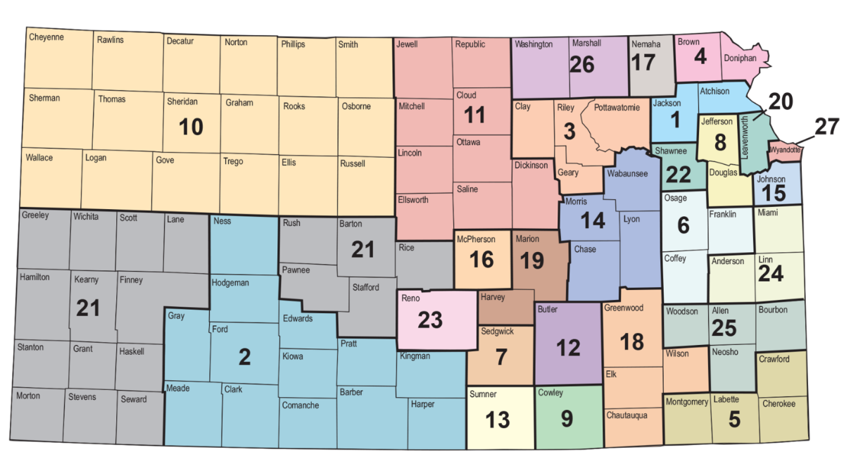
If you move from one community in Kansas to another, your funding goes with you. Once you have started receiving services, you will continue to receive services as long as you still live in Kansas, you remain eligible for services, and the funding is available.

1 – Achievement Services for Northeast Kansas (913) 367-2432
2 – Arrowhead West, Inc. (620) 227-8803
3 – Big Lakes Developmental Services, Inc (785) 776-9201
4 – Brown County Developmental Services, Inc (785) 742-3959
5 – CLASS, Ltd (620) 429-1212
6 – East Central Kansas Area Agency on Aging (785) 242-7200
7 – Sedgwick County CDDO (316) 660-7630
8 – Cottonwood, Inc (785) 842-0550
9 – Cowley County CDDO (620) 441-4504
10 – Developmental Services of Northwest Kansas, Inc (785) 625-5678
11 – Disability Planning Organization of Kansas (785) 823-3173
12 – Butler County CDDO (316) 322-8777
13 – Futures Unlimited, Inc (620) 326-8906
14 – Hetlinger Developmental Services, Inc (620) 342-1087
15 – Johnson County Developmental Supports (913) 826-2626
16 – McPherson County CDDO (620) 241-6693
17 – Nemaha County Training Center (785) 336-6116
18 – New Beginnings Enterprises, Inc (620) 325-3333
19 – Harvey-Marion County CDDO (316) 283-7997
20 – Riverside Resources, Inc (913) 651-6810
21 – Southwest Developmental Services, Inc (620) 275-7521
22 – Shawnee County CDDO (785) 232-0597
23 – Reno County CDDO (620) 663-2219
24 – Tri-Ko CDDO, Inc (913)256-7021
25 – Prairie Ridge CDDO (620) 431-7401
26 – Twin Valley Developmental Services, Inc (785) 747-2251
27 – Wyandotte County CDDO (913) 573-5502
Eligibility Definition

STATE OF KANSAS
DEPARTMENT OF SOCIAL AND REHABILITATION SERVICES MENTAL HEALTH AND DEVELOPMENTAL DISABILITIES

SUBJECT: Definition of Intellectual Disability and Other Developmental Disabilities for the purpose of
Program Administration

DATE: July 1, 1992 EFFECTIVE: October 1, 1993

NUMBER: MRDD 92-1 REVISED: November 15, 1995

BACKGROUND: Consistent with L. 1995, Chap. 234 (Substitute for H.B. 2458) persons who are
Intellectually disabled or otherwise developmentally disabled are those whose condition presents an extreme variation in capabilities from the general population which manifests itself in the developmental years resulting in a need for life long interdisciplinary services. The following identifies those who, among all persons with disabilities, are the most disabled as defined below:

Intellectual Disability means substantial limitations in present functioning that is manifested during the period from birth to age 18 years and is characterized by significantly sub-average intellectual functioning existing concurrently with deficits in adaptive behavior including related limitations in two or more of the following applicable adaptive skill areas:

1. Communication
2. Self-care
3. Home living
4. Social skills
5. Community use
6. Self-direction
7. Health & safety
8. Functional academics
9. Leisure
10. Work

Other Developmental Disability means a condition such as autism, cerebral palsy, epilepsy, or other similar physical or mental impairment (or a condition which has received a dual diagnosis of Intellectual Disability and Mental Illness) and is evidenced by a severe, chronic disability which::

1. is attributable to a mental or physical impairment or a combination of mental and physical impairments, AND

2. is manifest before the age of 22, AND

3. is likely to continue indefinitely, AND

4. results in substantial functional limitations in any three or more of the following areas of life functioning:

a. self-care,
b. understanding and use of language, c. learning and adapting,
d. mobility,
e. self-direction in setting goals and undertaking activities to accomplish those goals,
f. living independently,
g. economic self-sufficiency, AND

5. It reflects a need for a combination and sequence of special, interdisciplinary or generic care, treatment or other services which are lifelong, or extended in duration and are individually planned and coordinated, AND

6. Does not include individuals who are solely severely emotionally disturbed or seriously and persistently mentally ill or have disabilities solely as a result of infirmities of aging.

For Children under the age of six, developmental disability means a severe, chronic disability that meets all of the following criteria:

1. is attributable to a mental or physical impairment or a combination of mental and physical impairments, AND

2. is likely to continue indefinitely, AND

3. results in at least three developmental delays as measured by qualified professionals using appropriate diagnostic instruments or procedures, AND

4. reflects a need for a combination and sequence of special, interdisciplinary, or generic care, treatment, or other services which are lifelong or extended in duration and are individually planned and coordinated, AND

5. does not include individuals who are solely severely emotionally disturbed or seriously and persistently mentally ill.

I/DD Waiver Services
Residential Supports
Residential supports allow individuals to live in the community, safely, with as much independence as possible. A Residential Service can mean anywhere from living in the community by oneself and staff stopping by once a day, to living in a home that is staffed 24/7. These services are provided for individuals 18 years of age or older, and must occur in a setting, without regard to siblings, where the person does not live with someone who meets the definition of family and are provided by entities licensed by KDADS-CSP. This service provides assistance, acquisition, retention, and/or improvement in skills related to activities of daily living such as but not limited to: Personal grooming, Cleanliness, Bed making, Household chores, Eating, Food preparation, Social and adaptive skills necessary to enable the individual to reside in a non-institutional setting.

Shared Living is a housing option where people in the community open their doors to a person or persons with developmental disabilities. The providers and the people they serve learn and grow from each other in new and unexpected ways. These services are provided for individuals 18 years of age or older, and must occur in a setting, without regard to siblings, where the person does not live with someone who meets the definition of family and are provided by entities licensed by KDADS-CSP. This service provides assistance, acquisition, retention, and/or improvement in skills related to activities of daily living such as but not limited to: Personal grooming, Cleanliness, Bed making, Household chores, Eating, Food preparation, Social and adaptive skills necessary to enable the individual to reside in a non-institutional setting.

Day Supports
Day supports assist individuals in being a part of their community. These services are provided by KDADS-CSP licensed entities for individuals 18 years of age or older. These services include regularly occurring activities that provide a sense of participation, accomplishment, personal reward, personal contribution, or employment opportunities and thereby serve to maintain or increase adaptive capabilities, productivity, independence or integration and participation in the community. Day Supports also include the provision of pre-vocational services which are aimed at preparing an individual for paid or unpaid employment, but are not job-task oriented.
These services include teaching such concepts as following instructions, attendance, task completion, problem solving and safety. Such activities shall be appropriate for or lead to a lifestyle as specified in the individual’s Person Centered Support Plan. These opportunities can include: Socialization, Recreation, Community inclusion, Adult education, & Skill development in the areas of employment, transportation, daily living, self-sufficiency, and resource identification and acquisition.

Supported Employment
Supported Employment is competitive work in an integrated setting with on-going support services for individuals who have IDD. Competitive work is defined as compensated work in accordance with the Fair Labor Standards Act. An integrated work setting is a job site that is similar to that of the general work force. Such work is supported by any activity needed to sustain paid employment by persons with disabilities.
Wellness Monitoring
This is a process whereby a registered nurse evaluates the level of wellness of a consumer to determine if the consumer is properly using medical health services as recommended by a physician and if the health of the consumer is sufficient to maintain him/her in his/her place of residence without more frequent skilled nursing intervention. This includes Personal hygiene, Blood pressure, Pulse, Edema, Respiration, and Adjustments to medication.
Specialized Medical Care
This service provides long-term nursing support for medically fragile and technology dependent individuals. The required level of care must provide medical support for a beneficiary needing ongoing, daily care that would otherwise require the beneficiary to be in a hospital. The intensive medical needs of the beneficiary must be met to ensure the person can live outside of a hospital or IFC/ID. For the purpose of this waiver, a provider of specialized medical care must be a registered nurse (RN), a licensed practical nurse (LPN) under the supervision of an RN, or another entity designated by the Kansas Department for Aging and Disability Services.
Providers of this service must be trained with the medical skills necessary to care for and meet the medical needs of beneficiaries within the scope of the State’s Nurse Practice Act. The service may be provided in all customary and usual community locations including where the beneficiary resides and socializes.
Medical Alert Rental
This service provides support to a consumer who has a medical need that could become critical at any time. The medical alert device is a small instrument carried or worn by the consumer which, by the push of a button, automatically dials the telephone of a predetermined responder who will answer the call for help. The following are examples of medical needs that might require this service: quadriplegia, severe heart conditions, difficult to control diabetes, severe convulsive disorders, severe chronic obstructive pulmonary disease, & head injury.
Agency-Directed Supports
Personal Care Services (Supportive Home Care) are provided by an Agency (not self-directed by the person receiving services) to assist a person living with someone meeting the definition of family or a child in custody. Family is defined as any person immediately related to the individual. Specifically: Parents (including adoptive parents), grandparents, spouses, aunts, uncles, siblings, first cousins and any step-family relationships. These are individualized (one-to-one) services that provide direct assistance with: Daily living/personal adjustment, Attendant care, Assistance with meds that are ordinarily self-administered, Accessing medical care, Supervising/Reporting changes in condition & needs, Extension of therapy services, Ambulation/exercises, Household services essential to health care at home or performed in conjunction with assistance in daily living (shopping, preparing meals, bathing, using appliances, dressing, feeding, doing laundry, & cleaning). It is the expectation that individuals who need assistance with instrumental activities of daily living (IADL) tasks receive those supports from informal supports, if available. These informal supports may include relatives or friends that live with the individual and should be relied on for IADL assistance unless there is extenuating or specific circumstances that have been documented.
Enhanced Care Services provide supervision and/or non-nursing physical assistance during a person’s normal sleeping hours in his/her place of residence. ECS are available to a person who demonstrates a need of a minimum of 6 hours of sleep support within a 24-hour period. The assessed need cannot be met by the use of personal emergency response services, informal supports, or another service. The ECS worker shall be available to provide immediate supervision or physical assistance with tasks such as, but not limited to, toileting transfers, mobility, and medication reminders. The ECS worker shall be prepared and capable of contacting a doctor, hospital, or medical professional in the event of an emergency. ECS can be provided as self-directed or agency-directed services.
Self-Directed Supports
This array of supports consist of Financial Management Services, Personal Care Services, Overnight Respite Care, and Sleep Cycle Support and are available to individuals who reside with a person/persons who meet the definition of family or in a setting that would otherwise be licensed. These services provide necessary support for individuals in order to meet their daily living needs and/or to ensure continuation of stay in their current setting. These services also provide for paid staff to perform essential in-home assistance any hour of the day or night, in the absence or presence of non-paid care givers, as determined to meet the individual’s needs. Family is defined as any person immediately related to the individual.
Personal Care Services allows the person to self-direct residential supports, day supports, or supports in their family home. These services provide necessary one-on-one assistance both in the home and community. This service includes assisting with activities of daily living such as bathing, grooming, toileting, transferring, health maintenance activities, feeding, mobility and exercises, socialization and recreational activities. The PCS supports the individual in accessing medical services and normal daily activities by accompanying the individual to accomplish tasks based on their assessed needs. It is the expectation that individuals who need assistance with instrumental activities of daily living (IADL) tasks receive those supports from informal supports, if available. These informal supports may include relatives or friends that live with the individual and should be relied on for IADL assistance unless there is extenuating or specific circumstances that have been documented in the plan of care. No time will be allowed on the Plan of Care for PCS to complete activities that can be provided by the informal supports.
Overnight Respite Care services are provided to individuals who live with someone meeting the definition of family or are provided to children in custody residing in a setting that does not meet the definition of family. Respite Care is designed to provide relief for the individual’s family member who serves as an unpaid primary care giver. Respite is necessary for families who provide constant care for individuals so family members are able to receive periods of relief.
Enhanced Care Services provide supervision and/or non-nursing physical assistance during a person’s normal sleeping hours in his/her place of residence. ECS are available to a person who demonstrates a need of a minimum of 6 hours of sleep support within a 24-hour period. The assessed need cannot be met by the use of personal emergency response services, informal supports, or another service. The ECS worker shall be available to provide immediate supervision or physical assistance with tasks such as, but not limited to, toileting transfers, mobility, and medication reminders. The ECS worker shall be prepared and capable of contacting a doctor, hospital, or medical professional in the event of an emergency. ECS can be provided as self-directed or agency-directed services.

Tri-Ko, Inc. CDDO Affiliated Providers
Targeted Case Management

A Step Above, LLC (Sara Cuevas) scuevas.astepabove@gmail.com
19825 Rosewood, Stillwell, KS 66085 Tel: (913) 522-7523
Lakemary Center (Travis Chapman) Travis.Chapman@lakemary.org
100 Lakemary Drive, Paola, KS 66071 Tel: (913) 557-4000
Tranquility Case Management, LLC (Jeanette Bernhard) tranquilityTCM@gmail.com
6700 W. 97th St. Overland Park, Ks 66212 Tel: (913) 735-5782
Tri-Ko, Inc. (Heather Wier) heather_wier@tri-ko.com
301 First St., Osawatomie, KS 66064 Tel: (913) 755-3025

Residential Service Providers

Agape’s Grace, Inc. (Anthony Juarez) anthonyagapesgrace@gmail.com
S 2 Mulberry St, Louisburg, KS 66053 Tel: (913) 526-2817
AbleLight Inc. (Thomas Beattie) thomas.beattie@ablelight.org
14817 W. 95th St., Lenexa, KS 66215 Tel: (314)-222-7962

Lakemary Center (Travis Chapman) Travis.Chapman@lakemary.org
100 Lakemary Drive, Paola, KS 66071 Tel: (913) 557-4000
Tri-Ko, Inc. (Joshua Lankton) joshua_lankton@tri-ko.com
301 First St, Osawatomie, KS 66064 Tel: (913) 755-3025

Day Service Providers

Agape’s Grace, Inc. (Susan Juarez) anthonyagapegrace@gmail.com
2 S Mulberry St, Louisburg, KS 66053 Tel: (913) 526-2817
AbleLight Inc. (Thomas Beattie) thomas.beattie@ablelight.org
14817 W. 95th St., Lenexa, KS 66215 Tel: (314)-222-7962

Lakemary Center (Travis Chapman) Travis.Chapman@lakemary.org
100 Lakemary Drive, Paola, KS 66071 Tel: (913) 557-4000
Tri-Ko, Inc. (Joshua Lankton) joshua_lankton@tri-ko.com
301 First St, Osawatomie, KS 66064 Tel: (913) 755-3025
Goodlife Innovations (Dakota McNett) dakotamcnett@mygoodlife.org
201 West Street, Iola, KS 66749 Tel: (620)365-7119

Specialized Medical Providers

CareStaf (Stacy White) www.carestaf.com
2603 Challenger Tech Court STE 180 Orlando, FL 32826 Tel: (913) 498-2888

Personal Care Assistance (Self-Directed Financial Management Services)

Another Day, Inc. (Rebecca Gurera) rebecca@helpersinc.org
15540 Pflumm Rd, Olathe, KS 66062 Tel: (913) 322-7212
GT Independence (Erica Miller) CustomerService_KS@GTIndependence.com
2015 Broadus St., Sturgis MI 49091 Tel: (269) 651-4500
Helpers, Inc. (Rebecca Gurera) rebecca@helpersinc.org
15540 Pflumm Rd, Olathe, KS 66062 Tel: (913) 322-7212
Life Patterns, Inc. (Jon Gerdel) jon@lifepatternsks.org
3625 SW 29th St Suite 202, Topeka, KS 66614 Tel: (785) 273-7189
Resource Center for Independent Living (Deone Wilson) info@rcilinc.org
PO Box 257, 1137 Laing, Osage City, KS 66523 Tel: (785) 528-3106
Southeast KS Independent Living Center (Shari Cotney) www.skilonline.com
1801 Main, PO Box 957, Parsons, KS 67357 Tel: (620) 421-5502

In-Home Supports (Agency-Directed Financial Management Services)

ChristLove Home Care, LLC (Anne Vouidibio) avouidibio@christlovehomecare.com
PO Box 4680, Olathe, KS 66063 Tel: (913) 210-6077

Assistive Services
__________________________________________________________________________________________________
Southeast KS Independent Living Center (Shari Cotney) www.skilonline.com
1801 Main, PO Box 957, Parsons, KS 67357 Tel: (620) 421-5502

Foster Care Provider
__________________________________________________________________________________________________
KVC Behavioral Healthcare (Kimberly Hultgren) khultgren@kvc.org
21344 W. 153rd Street, Olathe, KS 66061 Tel: (913)-499-8100
Lakemary Center (Travis Chapman) Travis.Chapman@lakemary.org
100 Lakemary Drive, Paola, KS 66071 Tel: (913) 557-4000
TFI Family Services (Ashley Burnett) aburnett@teammns.org
www.tfifamily.org Tel: 785-338-8935

Medical Alert Rental
__________________________________________________________________________________________________
Home Buddy, LLC (Natalie Cole) office@homebuddy.org
3510 W. Central Ave. Suite 100, Wichita, KS 67203 Tel: (866)922-8339
MedScope America Corporation (Jared Hoch) jhoch@medscope.org
222 W. Lancaster Ave., Paoli, PA 19301 Tel: (800) 645-2060 x719

Funding Sources and Services
Individual seeking Intellectual/Developmental Disability (I/DD) services
CDDO
(Determines eligibility for I/DD services)

Types of Funding

Type 1: Medicaid Funds (KanCare)
Type 3: Private Pay (provider discretion)
Type 2: State Aid

Targeted Case Management (TCM)
ICF-IID
HCBS I/DD Waiver
KanCare MCO determines service needs

Supported Employment
Supportive Home Care (Agency-Directed)
Day Supports
Residential Support

Overnight Respite Care
Enhanced Care Services
Specialized Medical Care
Personal Care Services
(Self-Directed)

Medical Alert Rental
Assistive Services
Wellness Monitoring

Statewide Waiting List
The Kansas Department of Aging and Disability Services (KDADS) maintains the statewide waitlist for individuals eligible to receive services through the HCBS IDD waiver. To be added to the waitlist, an individual must be a legal resident of Kansas, determined to meet IDD eligibility requirements, and have scored Tier 1 through 5 on their most recent functional assessment (BASIS). An individual can also not be on the IDD waiting list if they are a recipient of other waiver services, with the exception of the Severe Emotional Disturbance (SED) waiver. If an individual moves outside Miami, Anderson, and Linn County area but remains in Kansas, they still retain their spot on the waiting list.
When KDADS determines that funding is available to an individual on the waiting list:
- The CDDO, along with KDADS, notifies the person or the person’s guardian and schedules a functional assessment.
- The CDDO, in cooperation with the targeted case manager, will inform the person or the person’s guardian of available service options and assist them in choosing providers. The person and their guardian will also meet with their KanCare Managed Care Organization (MCO) Care Coordinator to complete the Person Centered SERVICE Plan (not to be confused with the Person Centered SUPPORT Plan drafted by the targeted case manager) which authorizes the funding and services necessary to meet the person’s needs.
- If someone declines funding when offered, their name is removed from the waiting list and they must reapply.

What is Targeted Case Management / Person-Centered Support Plan?

Case management services are those that assist the individual in gaining access to medical, social, education, and other needed services. Targeted case management includes any or all of the following services:
- Helps you set and reach desired goals
- Helps keep your services working (together and separately)
- Advocates for the people they serve (i.e. supporting their interests)
- Every eligible person can receive service coordination if he/she chooses
- Case management for eligible persons if funded through state and federal funds at no out-of-pocket cost to the consumer

Transition and Portability-Including the planning of and arranging for services to follow the person when the person:
- Moves from school to the adult world
- Moved from an institution to community alternatives
- Moves from one kind of service setting to another
- Moves from one provider to another provider
- Moves from one service area to another service area

Development of a specific support care plan that is based on the information collected through the assessment, specifying the goals and actions to address the medical, social, educational, and other service needs of the individual. The PCSP includes activities such as ensuring the active participation of the eligible individual, and working with the individual (or legal representative) and other to develop such goals, and identify a course of action to respond to the assessed needs of the eligible individual. The plan is written down/developed by the individual and their support network and it is approved in writing by the person and/or their guardian.

Who will help make and support the plan?
You as well as your family, guardians, friends, case manager, support staff, experts, co-workers, etc. This is a plan that is developed in collaboration with many different people. Every effort should be made to see that it reflects what you want your life to be. This is a shared responsibility.

What is included in a description of my life?
What type of setting in which you want to live. With whom you want to live. What work or other valued activity you want to do. With whom you want to socialize. In what social, leisure, religious, or other activities you want to participate. Everything in this outline would be addressed in the plan. If you cannot get everything you need, then the next best options should be identified.

What if I am not quite equipped to achieve my goals in life?
Your plan should include a list and description of things necessary to assist you to achieve your preferred lifestyle, such as: training, equipment, services, and natural supports (family, friends, and community resources).

Choosing or Changing Service Providers
If you are choosing a provider for the first time or interested in changing any providers you can do so at any time. To begin this process, contact the Tri-Ko CDDO at (913) 256-7021. Our eligibility specialist will then initiate a Choice Form with you to fill out that lists all affiliated providers in our area in an impartial way.

Dispute Resolution Process
You may contact the CDDO any time you have a concern about your services or follow the process outlined below:
Professional Mediation
Board of Trustees
State
Court of Law
Council of Community Members
CDDO Dispute Resolution
Internal Agency Grievance Policy
Targeted
Case Manager
Person Receiving Services

Abuse, Neglect, or Exploitation
Report Online: http://www.dcf.ks.gov/Pages/Report-Abuse-or-Neglect.aspx

If you suspect a child is being abused or neglected, please telephone the Kansas Protection Report Center at 1-800-922-5330. Every call is taken seriously and every effort will be made to protect your identity. Telephone lines are staffed 24 hours a day. In the event of an emergency contact your local law enforcement or call 911. For more information go to:
http://www.dcf.ks.gov/services/PPS/Pages/ReportChildAbuseandNeglect.aspx

To report suspected abuse, neglect or exploitation of an adult, please telephone the Kansas Protection Report Center at 1-800-922-5330. Every call is taken seriously. Telephone lines are staffed 24 hours a day. In the event of an emergency contact your local law enforcement or call 911. For more information go to:
http://www.dcf.ks.gov/services/PPS/Pages/KIPS/KIPSWebIntake.aspx

If you are a mandatory reporter and would like to report child or adult abuse or neglect electronically, please use the new Kansas Intake/Investigation Protection System: Mandated Reporter Portal - Prevention and Protection Services (ks.gov) when using the electronic report please make note of the first question at the top of the form indicating child or adult type.

Know Your Rights: Kansans with developmental disabilities are guaranteed the same rights that non-disabled Kansans have, unless otherwise limited by provision of law or court order. The following pages detail some specific rights.

Rights for Individuals with Intellectual/Developmental Disabilities (IDD)

The Community Developmental Disability Organization (CDDO) is responsible for carrying out the duties as described in Kansas law and regulation (K.S.A. 39-1801 et seq. and K.A.R. 30-63-1 and 30-64-01 et seq. and for purposes of CDDO compliance with K.A.R. 30-64-22(e)(2).

As an individual who is receiving services from the State of Kansas IDD Waiver or has been placed on the IDD Waiver waitlist, my core rights in connection with the CDDO are as follows:

1. The right to have help getting the community services of my choice once I have been determined eligible for the HCBS IDD Waiver by KDADS based on my disability and finances.

2. The right to choose which targeted case management services I’d like to receive, from a provider affiliated with my CDDO.

3. The right to choose whether or not I’d like to have a targeted case manager if I am currently on the IDD waiver waitlist.

4. The right to receive services without discrimination as to the severity of my disability. If I currently pose a clear and present danger to myself or the community, the Secretary of KDADS may decide that I am inappropriate for community services.

5. The right to receive services for which I have been determined eligible from my choice of community service provider. Once I have been found eligible and funds are available, I should receive the service I have chosen, or it should be reported to the Secretary of KDADS that I am waiting for that service.

6. The right to continue to receive services for which I am eligible as long as state or federal funding support continues. I also have the right to transfer that level of state and federal financial support if I move from one service area to another within the state of Kansas.

7. The right to take advantage of the CDDO dispute resolution process, including internal and external appeal procedures to settle any disagreement with the CDDO, any affiliate, or any other component of the community service system.

8. The right to receive information regarding the CDDO local Quality Assurance Committee and Council of Community Members.

9. The right to receive information about self-advocacy groups.

10. The right to receive services provided in a way that is based on my Person-Centered Support Plan (PCSP) and listed in my Person-Centered Service Plan (PCSP). My services must offer me opportunities for choice and ensure that all of my rights are respected and protected, including those listed in K.A.R. 30-63-22.

As an individual who resides in an Intermediate Care Facility which services Individuals with Intellectual Disabilities (ICF/IID), my core rights in connection with the CDDO according to Kansas law and regulations (K.A.R. 30-64-22 and 30-64-29) include the following:

1. The right to have equal access to services if I am referred to the CDDO for possible services.

2. The right for myself or my guardian (if one has been appointed) to receive information at least once a year offered in a way that is easy to understand, including:

a) The types of community services available in my area and information about the providers of those services; and

b) My rights as described in the Developmental Disabilities Reform Act and implementing
Regulations. The commission will approve the content of this information.

3. The right for myself, my family, and my guardian (if one has been appointed) to receive information on services or supports that are currently available or could be made available within 90 days in or near my home county once eligibility has been achieved.

4. The right to have the CDDO offer to provide or arrange to provide these services and supports when it’s time to do so.

Consumer Rights
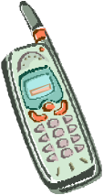

Others cannot hurt you physically or with words.
You have the right to
Privacy, when you want.

You have the right to basic needs
such as food, clothing, medical
care, and a home.
You can have visitors, mail, & phone calls where you live. You have the right to visit with friends and family in public
And in private.

You have the right to vote.

You have the right to choose and practice your religion or faith.

You have the right to manage your
own money to the extent you are
able, or you can receive help with it.

Medications that you take for behaviors are approved by you, before you take them.

Also, work is your choice. And you must be paid for your work.

You have the right to
Receive
Buy
& Use
Your own possessions.
You have the right to be treated with dignity and respect. Others should treat you fairly and the same as anyone else.

You have the right to see your records, file a complaint, or use the legal system.
You should always be included in discussions and decisions regarding your life, including your Person-Centered Plan

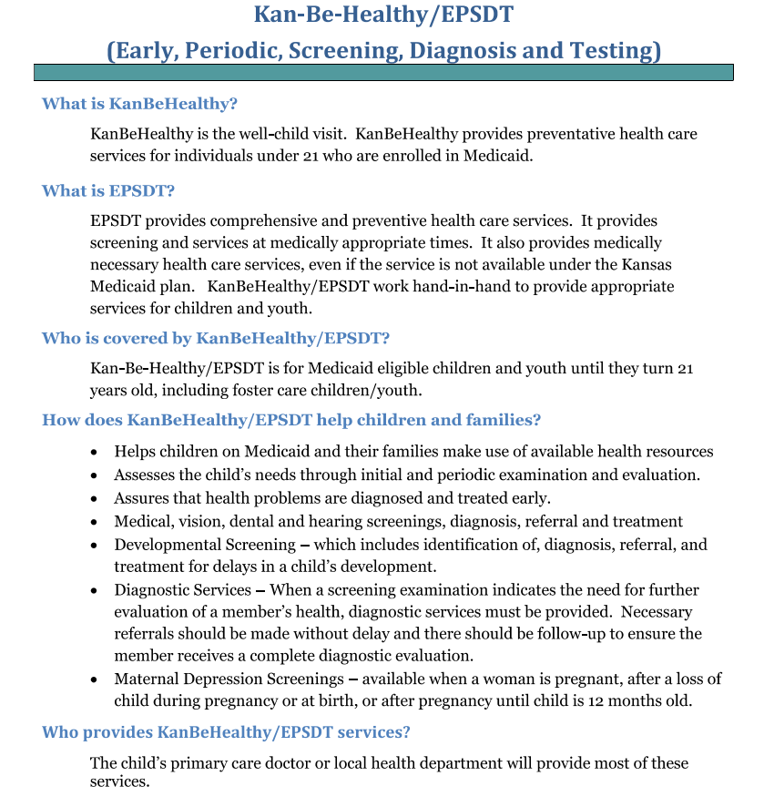

Do you know about Open Enrollment as a KanCare member?

You will receive your open enrollment packet 30 days before your one-year anniversary in KanCare. If you were added to someone's existing KanCare case, you will be up for open enrollment the same time as your family's case. After you receive your open enrollment packet, you will have until 60 days past your KanCare anniversary date to make changes to your KanCare health plan.

Open enrollment means you can change your plan if you want to be covered by a different plan, or you can keep your same health plan. If you are happy with your current health plan, you do not need to do anything at all. Again, if you do not want to change health plans, you will automatically be re-enrolled in your same plan. But if you want to change your health plan, you will need to let us know by following the instructions in the packet mailed to you on the anniversary date of when you joined KanCare. .

All members will have 60 days to review their open enrollment packet and decide whether or not they want to stay in their plan or change to a different plan.

For More Information Visit this Website:
www.kancare.ks.gov/providers/health-plan-information

There are 3 plans to choose from and 3 ways to choose your plan

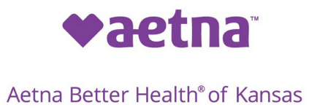

855-221-5656 877-644-4623 877-542-9235
TTY: #711 TTY: 888-282-6428 TTY: #771

1. Enroll online at: https://www.kmap-state-ks.us/hcp/member

2. Call the Enrollment Center at 1-866-305-5147 (TDD/TTY 1-800-766-3777)

3. Mail the KanCare Enrollment Form that you receive in your packet.

Things to Know

• Make a list of your providers—doctors, hospital, pharmacy, in home service providers, and any other providers you see. Check to make sure the providers you use for all services are signed up with the plan you choose.

• You must have active eligibility to stay enrolled with the plan each month.

• You will be able to change your plan one time each year. You will be told when you can make a change.

Health Plan Highlights

All physical, mental, and substance misuse services are the same in each MCO. Please contact your MCO by phone or theits website for additional details about the services they offer.
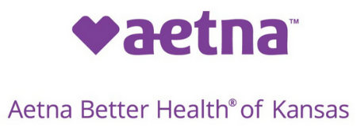

1-855-221-5656

Members 21 years and older receive $500 per year towards dental servicing: Dental exams/cleanings twice each year, Annual bitewing X-rays, Fillings and extractions and Fluoride treatments.

Healthy Rewards Incentive program where members can get $10-$25 gift cards when they complete wellness activities such as:
- Shots
- Yearly checkups
- Diabetic eye exams
- HbA1C tests
- Cervical Cancer Screenings

Free Android Smartphone with 350 minutes per month, 1 gigabyte, and unlimited text messaging for members 18 years and older.
- Health tips & reminders
- 1-on1 health care team texting
- Free calls w/member services
1-877-644-4623

Two dental visits (cleanings, screenings) for adults 21 and older every year. Children are covered under regular Medicaid benefits on most dental services. Dentures are covered for members receiving Frail & Elderly waiver benefits. Eligibility is based on determination of need.

Members can earn between $10-$50 in healthy rewards on a My Health Pays Visa Prepaid Card for receiving healthy checkups. Rewards can be used for utilities, transportation, telecommunications, childcare services, education, rent or everyday items at Walmart.

Free smart phone through SafeLink®. These come with free limited data and voice minutes per month, unlimited texting and free calls to and from Sunflower.

1-877-542-9235

Any member over age 21 can visit a participating dental provider to get screenings, x-rays, cleanings, and filling restorations. Members have a maximum benefit of $500 per year.
Dentures are covered for members receiving Frail & Elderly waiver benefits. Eligibility is based on determination of need.

Healthy rewards Program allows members to earn debit card credits between $10 and $25 to use in retail stores. Members can purchase health related items for doing healthy things like wellness checkups, immunizations, and flu shots.

You may be eligible for a free cell phone. Member Services can help you apply
The PROMISE Pregnancy Program includes:  - Gift Card Reward of $75 for a visit within the first trimester, within 42 days of plan enrollment and with notification of pregnancy to the Health Plan during the first trimester. Gift card can be used at specific retailers to purchase approved wellness items for mother and baby.  - Earn up to $150 in gift card rewards that can be used at specific retailers to purchase approved wellness items such as a stroller, portable crib, play yard, car seat, or a diaper and wipe package. Earn the rewards by going to pre and postnatal appointments. | Start Smart for Your Baby® program for pregnant members, babies and families. Start Smart offers nursing support, education and gifts. There is no cost to the member.  - In-home help with healthcare and community services  - Special texting program for Start Smart participants  - Community baby showers for pregnant members. Diapers and other gifts are included in these events.  - Birthday programs for children  - Transportation to WIC appointments.(Four round trips) | Complete you first prenatal in the first trimester (42 days) and earn a $200 debit card.  - Health First Steps: Build a healthy future for you and your baby and earn great rewards with Healthy First Steps. Our program will help you take the right steps to keep you and your baby healthy. Plus you can earn $20 just for signing up.  - Pest Repellent: Free bug spray to help protect against mosquito bites.
Additional Transportation Services – Free rides for members going to the pharmacy, WIC eligibility appointments and prenatal classes. Ten round trips per year for members going to job interviews, job training, shopping for work type clothing, food bank or grocery store for food and getting community health services otherwise not covered  GED test benefit of $130.  Members 21 and over get up to $50 per year towards upgraded lenses.  $25 per month of certain over the counter drugs & supplies  Diabetic members, 21 and over, receive 2 podiatry visits each year.  Certain wavier members, $250 towards pest control. | Sunflower Transition to Employment Program (STEP) is an employment support resource program. We help members identify and remove employment barriers through a discussion with an internal employment specialist. Benefits include enhanced transportation coverage, GED  Ready and GED test vouchers, connection with career counseling services, and information on the STEP scholarship program. Members may be connected with a benefits specialist to learn how their income may impact their benefits.  In-home telehealth is available for adults. This service helps members stay at home when they need help to manage their chronic conditions.  Members can receive produce vouchers worth $10 at special events with participating Farmers Markets  Members can participate in a smoking cessation program offered through Sunflower’s Healthy Solutions for Life program. Counseling treatment sessions are unlimited. | Up to 12 rides annually (10 miles each way) including the grocery store, food banks, pharmacy, prenatal classes, WIC, local community activities and job related activities. Up to $25 in annual Bus passes available to members in Sedgwick, Wyandotte and Johnson Counties  Members on the Physically Disabled, Frail & Elderly and Traumatic Brain Injury waivers can get six one-way or three roundtrip rides to social events.  On My Way (OMW) Program: Help prepare young adult members for adult life. OMW teaches skills like managing money, getting housing, finding job training and applying for college.  Help with getting your GED, classes to learn to code, English as a second language and resume writing.  Adults age 21 and over can get an additional $60 per year to use toward frames
Smoking Cessation for members 18 and over, Text2quit texting health program. Nicotine replacement therapy as prescribed by your doctor.  Members in an institutional setting between 60-90 days, grant offers up to $2500 for transitional funds.  Waiting list eligible for respite care, one background check for PCS worker. | Healthy Solutions for life: Targeted disease management for members with the following conditions:  - Asthma (adults and children);  - COPD (adults);  - Diabetes (adults and children);  - Heart disease (CAD) (adults);  - Hypertension (adults);  - Obesity weight management (adults)  The program also helps members determine how emotions affect their condition. It helps with stress, poor sleep, and appetite. As a part of the program, participants are assigned a Health Coach who works with the entire healthcare team. | Members can download Health4Me app on their phone to help health management.  Members, or those responsible for members, can access myUHC.com online to help access health history, educate members on working with their doctor, and track doctor visits.

To change plans call: 1-866-305-5147
Para cambiar planes llame: 1-866-305-5147

________________________________________________________________________________________

How Medicaid Consumers Received Notification about KanCare before January 1, 2013

Before KanCare launched in January 2013, member pre-enrollment packets were mailed to Medicaid consumers through the end of November 2012.

The Kansas Department of Health and Environment (KDHE) and the Kansas Department for Aging and Disability Services (KDADS) held educational tours across the state to meet with Medicaid consumers about their transition to KanCare. Also attending were representatives from the three health plans. For the latest news go to: https://www.kancare.ks.gov/

Home & Community Based Services Consumer Letters from 2012
Consumers who receive home and community based services (HCBS) got letters from the State in late
December 2012. The letters explained the changes for HCBS consumers that will happen with KanCare.

